December 18, 2022

Jose Mari Aldeguer, President & CEO

*Thru: Ms. Boots Morales, Finance Head*

Tangent Solutions, Inc.

Philippine Stock Exchange Centre - 15/F Suite 1507-A East Tower

Exchange Rd, Ortigas Center, Pasig, Metro Manila  
  
BILLING STATEMENT

Period Covered: November 01-30, 2022

Dear Sir:  
For the period covered, this is to bill you in the amount of Nine Thousand Pesos (P11,420.00) for the following services.

|  |  |  |  |  |
| --- | --- | --- | --- | --- |
| DATE | TIME | ACTIVITY | WORKED WITH | STATUS/% DONE |
| Wednesday, 02 November, 2022 | 12NN-1PM | Dataone-Tacacs ssh re-hardening | MSL | 100% |
| Thursday, 03 November, 2022 | 12NN-1PM | VITRO -Tacacs ssh re-hardening | MSL | 100% |
| Friday, 04 November, 2022 | 12NN-1PM | fixing Control Case account servers | MSL | 100% |
|  |  |  |  |  |
| Monday, 07 November, 2022 | 12NN-1PM | fixing "Failed to copy the CCSearchX64" errors from Control Case server. | MSL | 100% |
| Tuesday, 08 November, 2022 | 5:30 pm-12:00am | ixing NTP server syncing problem. fixing posdb posg kaspersky. fixing idm two factor authentication. meeting with sir MJ ang Jonathan | MSL, JGC | 100% |
| Wednesday, 09 November, 2022 | 12PM-5PM | Assisting sir MJ on showing radius and idm server configuration to ControCase auditor. 11 | MSL, JGC | 100% |
| Thursday, 10 November, 2022 | 8AM-11AM | fixing wazuh agents and fixing idm disconnected agents | MSL, JGC | 100% |
| Friday, 11 November, 2022 | 12NN-1PM | fixing tacacs server authentication problem | MSL | 100% |
|  |  |  |  |  |
| Monday, 14 November, 2022 | 12NN-1PM | re-installation of rapid7 on Vitro-Tacacs | MSL | 100% |
| Tuesday, 15 November, 2022 | 12NN-1PM | fixing dataone-tacacs connection to rapid7 server with assistant of Jonatahn | MSL | 100% |
| Wednesday, 16 November, 2022 | 12NN-1PM | re-installation of rapid7 on Dataone-Tacacs | MSL | 100% |
| Thursday, 17 November, 2022 | 12NN-1PM | reconfiguration of rapid7 on vitro tacacs | MSL | 100% |
| Friday, 18 November, 2022 | 12NN-1PM | reconfiguration of rapid7 on dataone tacacs | MSL | 100% |
|  |  |  |  |  |
| Monday, 21 November, 2022 | 12NN-1PM | fixing dataone idm server syncing problem. | MSL | 100% |
| Tuesday, 22 November, 2022 | 12NN-1PM | fixing vitro idm syncing problem. | MSL | 100% |
| Wednesday, 23 November, 2022 |  |  |  |  |
| Thursday, 24 November, 2022 |  |  |  |  |
| Friday, 25 November, 2022 | 12NN-1PM | assisting sir MJ on providing idm password policy evidence for control case | MSL | 100% |
|  |  |  |  |  |
| Monday, 28 November, 2022 | 12NN-1PM | assisting sir MJ on providing Kaspersky configuration evidence for control case | MSL | 100% |
| Tuesday, 29 November, 2022 | 12NN-1PM | NOC servers’ health check and maintenance | MSL | 100% |

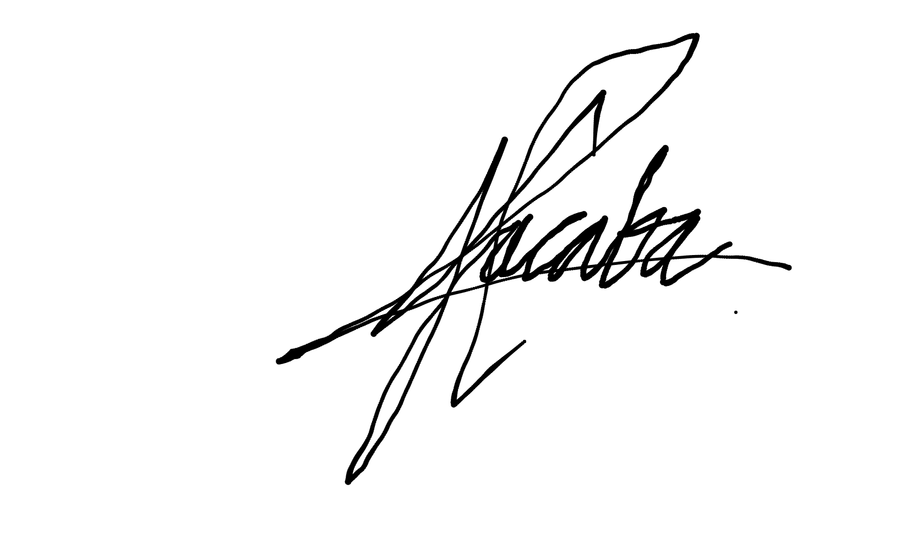

Signed:  
  
  
CARLO JAY I. JACABA

BIR TIN#: 3935894040000